ST PATRICK’S PRIMARY SCHOOL
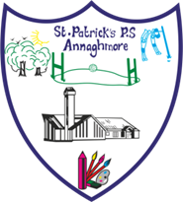
10, Annaghmore Coalisland, Co. Tyrone. N.I. BT71 4QZ
Principal: Anne Mc Guinness
Web Site: www.stpatricksannaghmore.com
Telephone :(028) 87740661
Email: info@stpatricksps.coalisland.ni.sch.uk

To all parents,

The Education Authority (EA) has warned of expected disruption to some school services as a result of industrial action notified by UNISON.
This action will consist of action short of strike from 16 October 2023 to 20 November 2023 as well as a full day of strike action on 16 November 2023.

“The EA is working with schools, youth services and partners to minimise any disruption to children and young people caused by the industrial action. However, despite this, there will be disruption to some services; at this stage the EA anticipate that the impact is likely to be most significant across some classroom assistant, catering and cleaning services and some EA Transport Services.

We encourage parents/carers to check the EA website for regular updates and details of any planned disruption here: www.eani.org.uk/industrialactionupdates

Information is also available across EA social media channels.

Thank you in advance for your understanding and support in relation to this.”

Yours sincerely,
Matthew McDermott
EA Assistant Director, Human Resources and Corporate Services

