“To be the best we can be every day, in every way!”
ST PATRICK’S PRIMARY SCHOOL
10, Annaghmore Coalisland, Co. Tyrone. N.I. BT71 4QZ
Principal: Anne Mc Guinness
Web Site: www.stpatricksannaghmore.com
Telephone :(028) 87740661
Email: info@stpatricksps.coalisland.ni.sch.uk
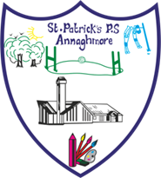

Wednesday 3rd June 2020
Good morning to all parents!!
I hope you and all your families are keeping well. Connor Lowe, one of our local uniform suppliers has asked me to forward to you information regarding ordering, collection and fitting arrangements for this during COVID19.
Connor says,
“In normal circumstances our back to school season can be quite hectic. With the current health crisis, we are taking measures that will enable parents to get their back to shop needs in a safe and unimposing manner. Therefore,
we would like all parents to visit our shop this summer by a prearranged appointment.
This can be done by making contact with us prior to their intended journey. Our contact details are ..........
Facebook & Messenger.Frank McGirr's
Telephone, 02887749752
Email, loweconnor3@gmail.com
We intend to extend our opening hours and Sunday afternoon opening will be an option also.”
Take care, keep safe and well,
Anne Mc Guinness (Principal)

