Easter Raffle Prizes
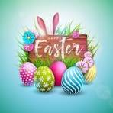
1st £200 Family Portrait -Collette Gribben
2nd Greenvale Hotel Voucher - Dovydas
3rd Large Easter Hamper – Niamh Quinn

• Emer O’Neill – Hair Management Gift Voucher (£20)
- Kerri McCann
- Make-Up & Hair Up-Do Voucher (Lisa Quinn) – Paul McKillen
• Begley’s Voucher – (£25) - Brenda Lappin
• Falls Bar & Off-Licence Voucher – (£25) -Oisin O’Neill
• Mc Cann’s Fuel Voucher – (£25) – Michelle Quinn
• ML Dental Hygiene Clinic Voucher – (Cost of Professional Scale & Polish Treatment) -Caitlin McGrath
CoCo Blush Voucher – Rose-Marie Kilpatrick
• Maria Nila Shampoo & Conditioner Gift Set – Aimee Devlin
• Clonoe Phone Repairs Gift Bag (Wireless charger; Smart PD Cable & Dual Mic Wireless Earphones) -Niamh McGlone
• Tropics Gift Set (Maggie McCloskey) – Brenda Lappin
• Dorman’s Healthcare Set – (Cocoa Cabana set) Sean Donnelly
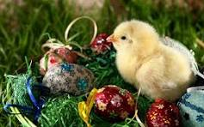
• Bottle Villa Maria White Wine – Paula McStravog
• Bottle Apothic Winemaker’s Red Wine – James Devlin
• Bottle Smirnoff Vodka – Eileen Taggart
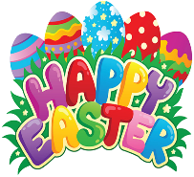
- Voucher for Bert’s Pizza – Claire Douglas
- Children’s Easter Egg & Goodies Baskets
Aidan Gates; Leah Molloy
Thank you to all who sponsored our prizes for our Easter Draw and to all who bought the tickets!

